# Creating an Eclipse Workspace and connecting to Github

## First Setup

1. Sign up for a GitHub account, using your RMIT email address:

<https://github.com/join>

1. Apply to have GitHub recognise your account as a student account:

<https://education.github.com/>

Detailed instructions here:

<https://help.github.com/en/articles/applying-for-a-student-developer-pack>

1. Make sure you have already installed “Eclipse” and “PyDev” as per previous instructions “Set up Eclipse for Python Development”.
2. Tell Tyler your GitHub username and email address. DO NOT PROCEED FURTHER until he has confirmed that he has added you to the GitHub repository as a collaborator, otherwise, you’ll only get so far, and get rejected.
3. Launch the Eclipse IDE. You will be asked to specify a workspace:

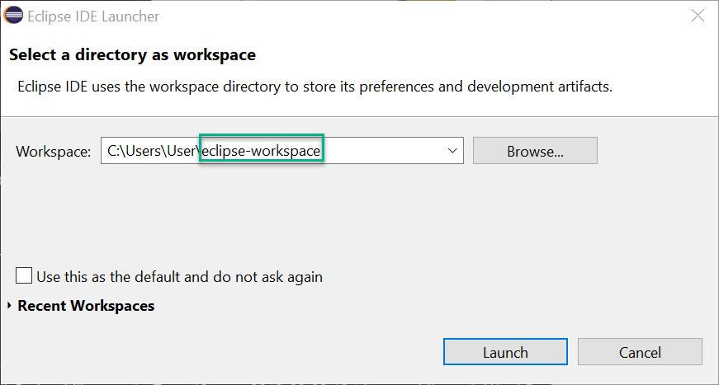

E.g. on my computer, it wants to put Eclipse workspaces into C:\Users\User by default, and it will default to using a workspace called “eclipse-workspace”. You should change “eclipse-workspace” to something specific to this project, so you can use other workspaces if you want to use Eclipse for other subjects. To test these instructions, I called mine “satellite-test-workspace” and hit “Launch”. It will create any necessary files/directories for you to set up the new workspace.

1. At the welcome screen, choose “Checkout projects from Git”

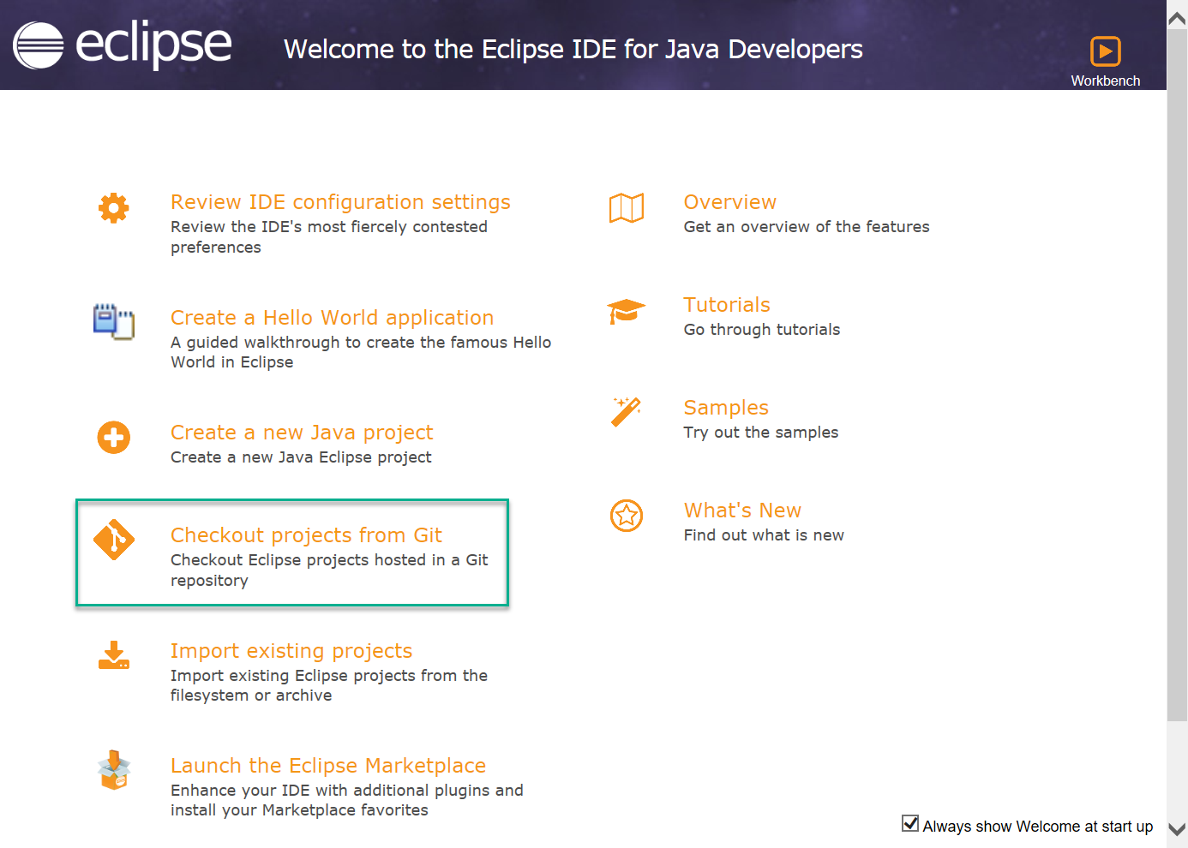

1. You will be shown the “Import Projects from Git” window. Choose “Clone URI” and then “Next >”

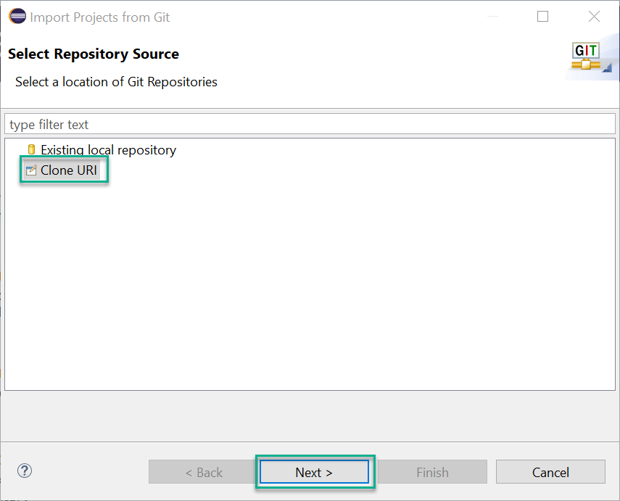

1. You will be asked to enter the details on how to connect to the GitHub repository. Enter the following details:

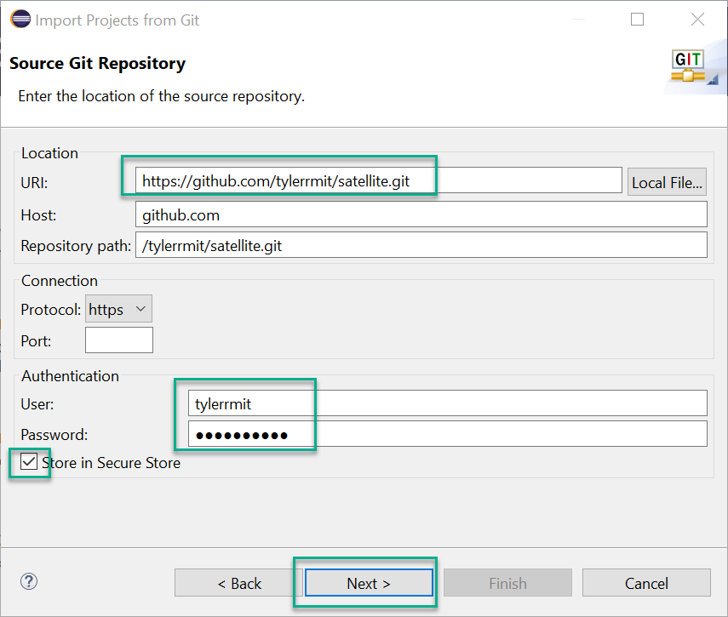

URI: <https://github.com/tylerrmit/satellite.git>

User: Your GitHub username

Password: Your GitHub password

Select [X] Store in Secure Store so that you don’t have to re-enter your username and password all the time

Then hit “Next >”

It will think for a second, then hit “Next >” again.

1. Tell Eclipse which directory to use as the “local storage location’ for the project:

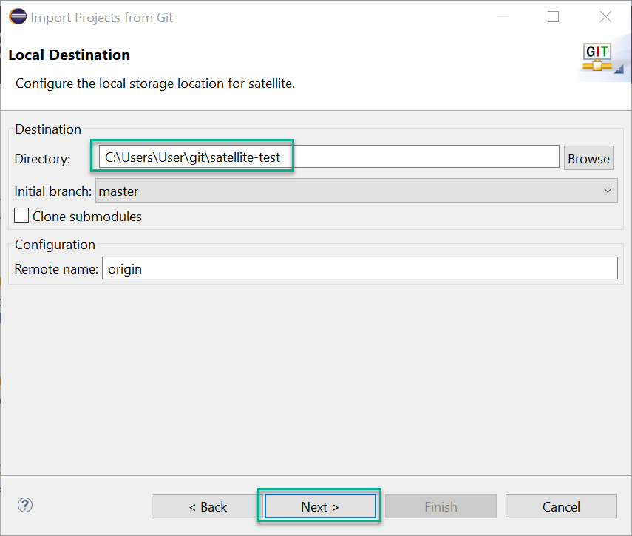

The default directory is probably fine. If the default directory already exists, and contains files, it will tell you no – just change to a new directory to make it stop complaining. Hit “Next >”.

It will think for a little while. Accept the default “Import existing Eclipse projects” then hit “Next >”

Hit “Finish”.

1. Tell Eclipse where to find the Python interpreters:

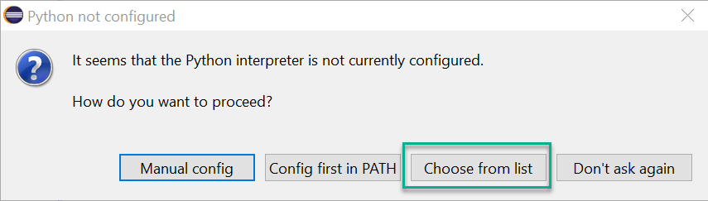

Choose “Choose from list”. Another window should pop up with the interpreter information you set up in our previous instructions “Set up Eclipse for Python Development”:

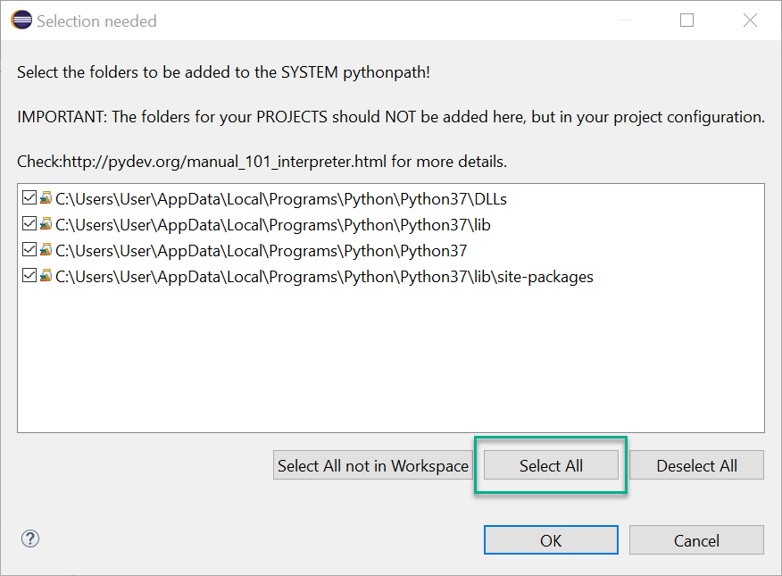

Make sure all four are checked (you can use “Select All” if they’re not) and then press “OK”.

It’ll think for a little while, starting with “Configure Interpreter” etc. When it’s finished, it will look like this:

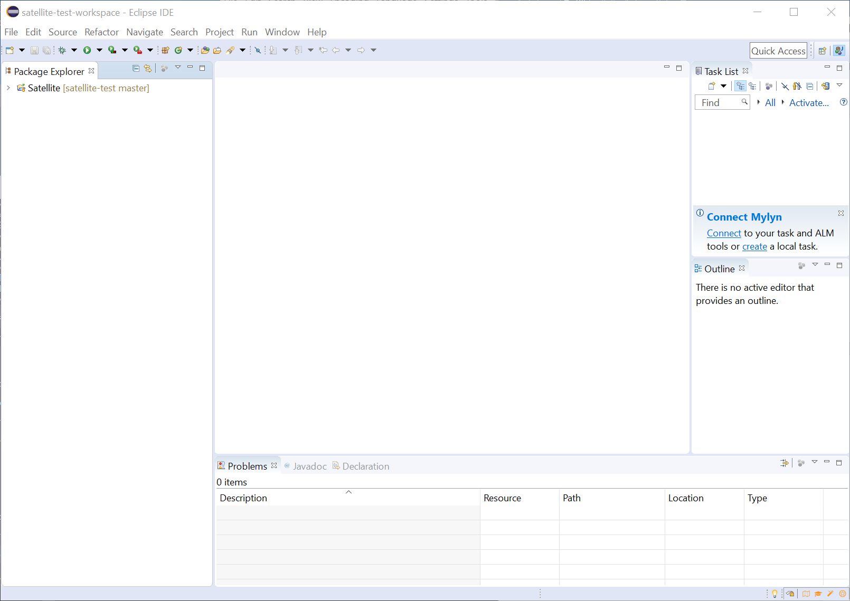

You can drill into the project to see all our files:

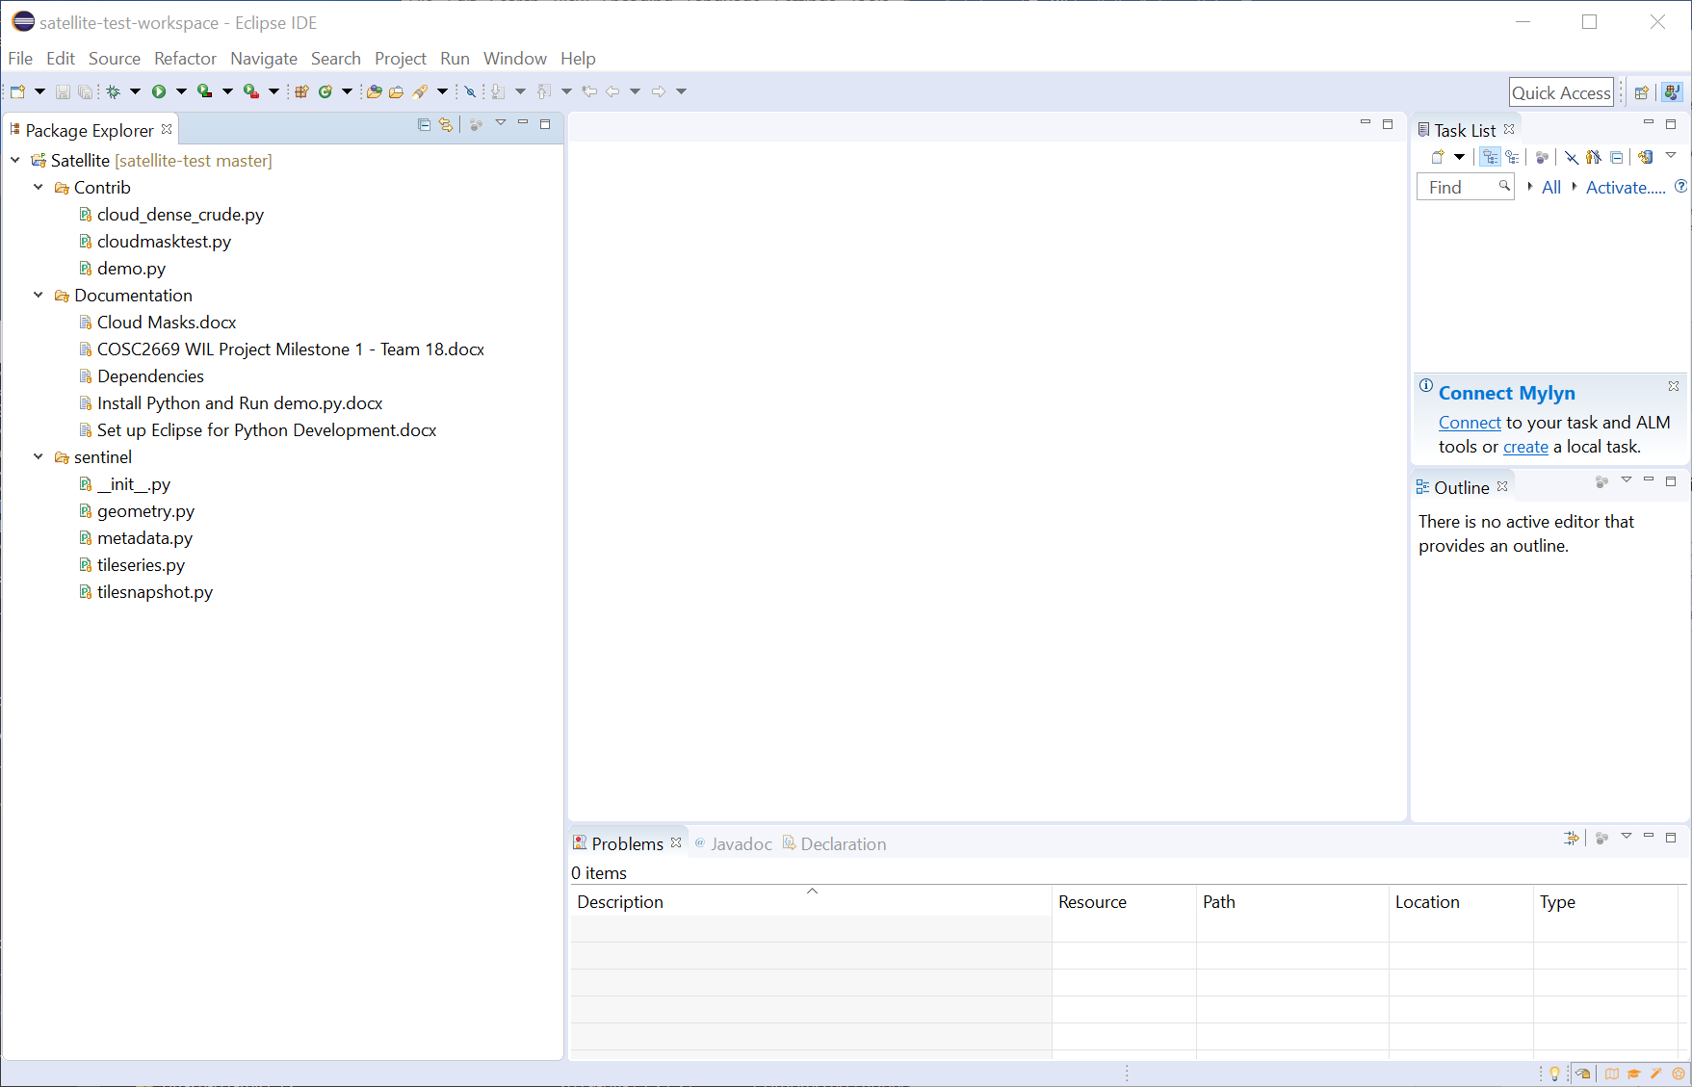

1. Check that you can run “demo.py”:

Find Satellite -> Contrib -> demo.py.

Right-click on it -> Run As -> Python Run. You will see errors because there’s no “data” in the working directory:

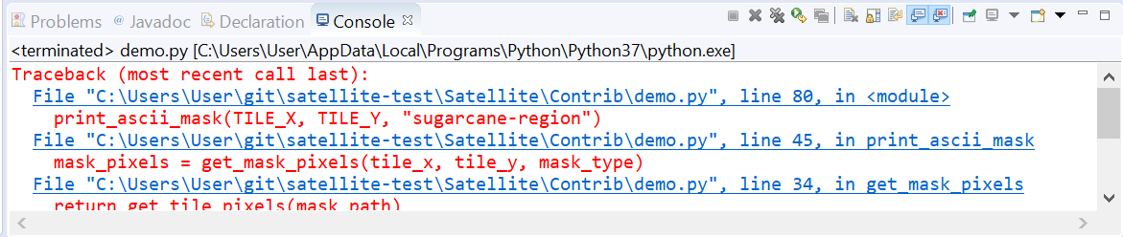

Right-click on “demo.py” again -> Run As -> Run Configurations…

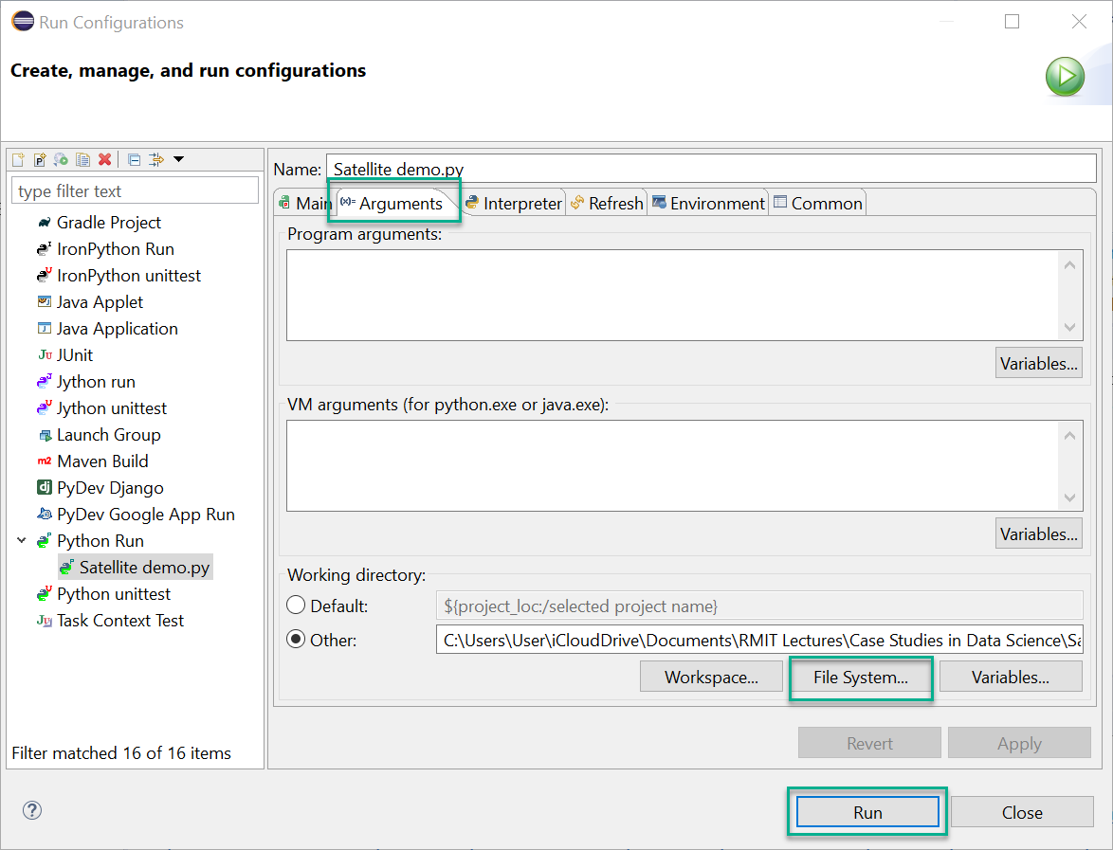

Go to the “Arguments” Tab, then under the “Working directory” section, choose “File System…” Choose the folder *containing* the “data” folder where you unpacked the Hackathon files. Then hit “Run”.

You’ll see a crude map full of “X” characters in your console, showing you that it worked:

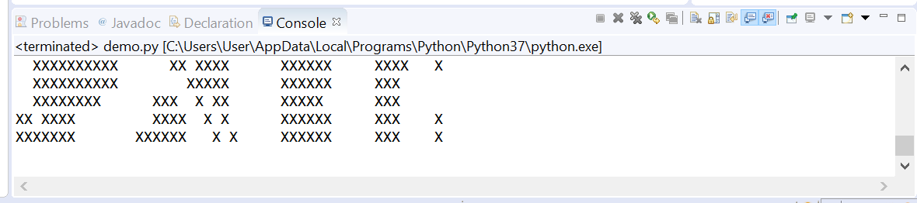

## Pulling down changes

To grab the latest changes from the change repository – perhaps because someone else has added/updated files for their task:

Right-click on the “Satellite” project in the Package Explorer -> Team -> Pull

If you already have the latest version of everything, you’ll see this:

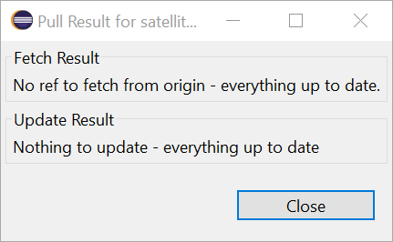

I recommend that you “pull” the latest code/files before you start anything new, to avoid unnecessary “conflict” between what someone else already did and what you’re about to do (to the same file(s))

## Committing and Pushing changes

When you’ve made changes, Right-click on the “Satellite” project -> Team -> Commit…

xxx